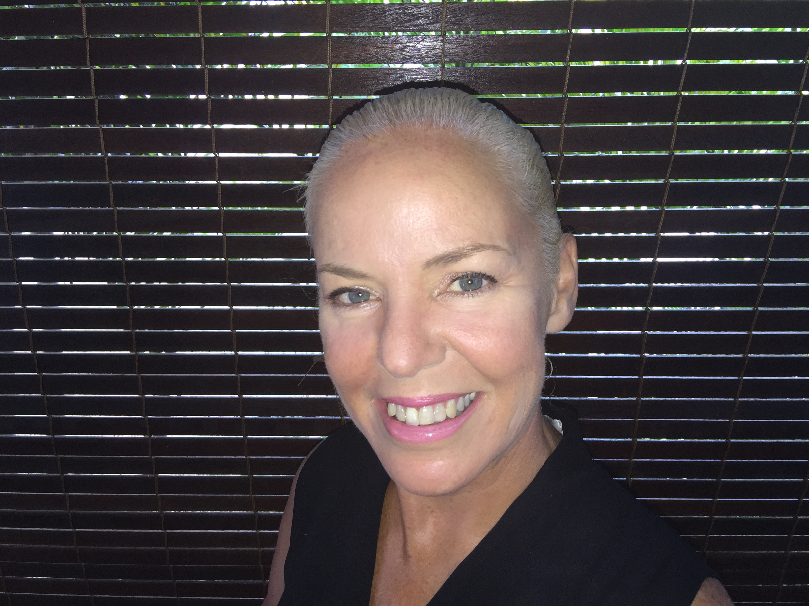

PENNY JONES
● Mass Display Choreographer and Director

● Consultant

Penny Jones
Contact Details: +27 82 920 8170/ penny@show.co.za
Skype: penny.jones za

PENNY JONES
● Stadium Theatre Producer  Mass Display Choreographer

● Consultant

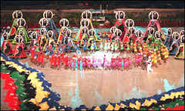

Penny Jones is an internationally renowned Mass Display Choreographer and Director, Producer and Consultant

“Creative, Focused, Disciplined, Resourceful, Energized, Meticulous, Professional, Passionate, Inspired, Effective, Organized, in Control. Gracious and Fabulous.”

Awards

International Toastmasters Award for Leadership and Communication

SA Tourism Chairman’s Award

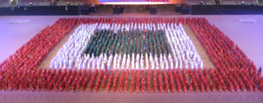
Intro to Penny Jones

Penny Jones is a World Class expert in the area of Mass Display Choreography and Logistics . Her Training in Fine Arts (BA FA) along with her keen attention to detail and precision as a result of her award winning Drill Team experience, have resulted in her high levels of creativity and expertise particularly in the areas of Show Design, Mass Display Design and Charting.

Her experience as an Executive Producer has also led to her keen understanding of all related departments required for the successful delivery of Stadium Shows as well as the Leadership and EQ skills required. This broadbased understanding allows Penny Jones to provide unique value to her Clients as per the agreed scope.These competencies include Knowledge and awareness of the following areas:

- Stakeholder Management-Liason with Ministry of Arts and Culture, Sponsors, City and Provincial Committees
- Project Management-Project Assistants, Client Services, Master Budget,Funding, Project Plan, Risk Management, Suppliers Contracts, Asset Management, Office Management, PR and Media Briefings.
- Skills Tranfer and local Cultural Interface.
- Creative Team-Theatrical, Dramaturg, Script Creation and Updates, Music/ Soundscape, Design Team- Video Graphics, Set Designer, Software Designer, Script Writer, Props Design, Costumes Design, Hair and Make-up Design, Lghting Design, Sound design. Pyro and Special Effects Design, Segment Producers, Programe
- Protocol Department- VIP Speeches, Flag Raising, Parades and Fly Pasts. Medal Ceremonies.
- TV Department , Multiple Broadcast Units, Camera Rehearsals, Recommended Camera shots, Credits List.
- Operations General-Health & Safety, Logistics, Accreditation, Catering, Transport, Travel and Accommodation, Security, Medical.
- Operations Site Specific: Overlays, Site Management, Plants and Equipment, Fittings and Fixtures, Structures, Freight and Handling, Rehearsal Days, Waste Management.
- Technical Management-Staging, Rigging, Mechanical & Engineering, CAD and 3D plans, Aerial/Flying, Crew, Load in, Load Out, Production.
- Technical Services-Lighting, Pyro , Audio , Comms Loops, Data, Video, Power, Robotics.
- Costume Department-Wardrobe-Manufacture, Fittings and alterations, Maintenance and Storage, Distribution and Collection.Hair and Make-up.
- Props Department-Manufacture, Storage and Maintenance, Distribution and Collection.
- Cast Department-Volunteer Cast, Volunteer Cast Co-ordinators, Marketing, Public Authorities Liason, Media Liason, Agreements and contracts, Cast Data Base, Auditions, Rehearsal Bibs,Scheduling, Chaperones, Cast Care Packs and Awards
- Cast Department-Professional Cast, Artist Ryders, VIP Cast Care and Management
- Audience Participation Programs-Audience Leaders, Audience Packs, Audience Training
- Stage Management Department-Stage Manager Assistants, Show Caller, Script Management, Show Cueing and stacking orders, Spectators, Services, Screen/s, Rehearsal Schedule, Rehearsal Preparation and Pack Up, Department Liasons, Cast Movement Plan, Choreography Mark Out, Show Management.

With a career spanning over 3 x decades ,Penny Jones started in South Africa after completing a degree in Fine Arts from the University of Cape Town. Her creative ability and mathematical mind lent to a love for “Majorettes” and she was soon in demand for local shows and events. After many successful deliveries in South Africa culminating in her co-producing the 1999 All Africa Games Ceremonies and being awarded the position of Executive Producer for the ICC 2003 Cricket World Cup Ceremonies Penny chose to focus on the area of Mass Display. Penny is headhunted for key projects around the world and has works primarily in Africa, Middle East and Europe.

Penny Jones works as an individual, however as she has developed a wide network of International Experts in this highly specialized field ,she can assist Clients build an appropriate Team if required.

More recently, Penny has added value to her Clients by incorporating a unique Training programe for local Mass Display Assistants and Team Members. This builds long term skills transfer and education in the specialized Art of Mass Display Choreography.

Penny Jones is happily married to Speaker, Author and Businessman, Ken Annandale and resides in Poste Lafayette, Mauritius. Penny and Ken often create a joint Team when travelling combining their unique strengths and abilities.

In Penny’s own words:

“I tap into the special Power of Human Mass Display Choreography to deliver my Client’s brief with creativity and flair. My years of experience in this highly specialized field gives me the advantage of being able to interpret my Client’s creative vision with clarity and speed involving all participants in a pleasant and positive environment.”

I fell in love with Mass Display Choreography in my young 20’s while studying my BA Fine Arts at the University of Cape Town.I was originally inspired by the precision and excellence of local South African School Drum Majorettes and the burgeoning Spectacles of TV Olympic Ceremonies as first exampled by the Los Angeles Olympics of 1984. I trained several School teams becoming South Africa’s first Professional Majorette Trainer. Armed with my creative flair and ability with Maths I soon won every National Title in all age groups and categories. This led me to travel to Los Angeles to take part in the annual “Miss Dance Drill Team” Pageant. It was here that I met Dr Kay Crawford (the mother of modern Drill Team). She encouraged me to participate in the “Drill Team World Championships” in Japan.

After winning my first International Drill Team Championship in Japan in 1994 I was invited to experience the final Dress Rehearsals of the Atlanta Olympics in 1996 in the USA. Taking part as an observer and camera stand-in-I was exposed to the magnitude of the power of Human Mass Display as directed and delivered by the legendary Don Minchner and Kenny Ortega and was hooked. Taking my learning’s back to South Africa I was able to present SA’s first multi demographic Mass Displays for top National, International Sports events and TV Spectaculars after the end of the Apartheid Era.I was even privileged to present a private display of mixed Afrikaans and Soweto performers at the bequest of the late President Nelson Mandela.

A turning point in my career was my acceptance on the elite Mass Display Choreography Team for the Sydney Olympic Ceremonies of 2000 in Australia. Working as a volunteer under the Directorship of Doug Jack and the Executive Producers Ric Birch and David Atkins, I was able to learn about moving a cast of thousands. Using this knowledge I was successful in winning the bid to produce the Cricket World Cup Opening Ceremony of 2003 in Cape Town SA which was an “Unqualified Success and the first Show of it’s kind in ICC Cricket World Cups”.

After a brief sabbatical looking after my Mother during her final fight against Cancer, I was then drawn into the magical world of TV Ads using Mass Display Choreography with an animated twist and won much interest and acclaim with the Akbank Series for a Turkish Bank. Working in Europe led to many other highly successful projects in a similar “Berkley Busby” genre and attracted the interest in my work from Production Companies working in the Middle East and Africa.

In 2008 I was the Mass Display Director for the Ghana Africa Cup of Nations in Accra and in 2009-2010 was appointed the Mass Display Director for the Oman 40th Celebration Spectacular in Muscat where I designed a Show and Training program able to deliver 12000 school children in 5 x Scenes from 60 x local schools.

My work continued with more excellent TV Ads for companies from Moscow and Egypt and a unique Flash Card event designed by the modern Artist Job Koelwyn for the reopening of the Rijksmuseum in Amsterdam in 2013.

One of my most significant projects saw the strength of Humanity being celebrated in a powerful Mass Display Ceremony for the “20 th Commemoration of the Genocide in Rwanda” at the Kigali Stadium in April of 2014 . The vision of Hope and the ability of Humans to rise up after near devastation was portrayed in a dignified moving motif using some 1000 local performers and Artists. This “beautifully choreographed “ pageant utilized the power of Mass Display Choreography in conveying an important message with dignity and excellence and was well received by the International Press and Dignitaries as well as the people of Rwanda.

In 2015 I decided with my husband and business partner Ken Annandale, to move my home base to the Indian Ocean Island of Mauritius. With excellent wi-fi support, we enjoy the opportunity to work with Clients all over the world while enjoying the balance of a warm outdoor lifestyle.

My 2020 vision is to explore innovative ways of delivering and directing Mass Choreography for my Clients incorporating the best of human movement and emotion with the latest technologies. I will also continue to empower the next generation of Mass Choreography specialists through “apprenticeships” and workshops.

My Mission is to be recognized as one of the best designers and Directors of Mass Choreography in the 21st Century

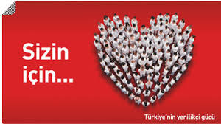

STADIUM EVENTS/CEREMONIES/TV Ad

2014 9th CAF African Women’s Soccer Championships Opening Ceremony in Windhoek, Namibia.
Mass Display and Staging Director. Creative design re Costumes, props and music. Incorporated Training Programe for local Mass Display Assistants. Show Consultant. Assistant to TV Director –calling camera shots in TV OB Van.

2014 20th Commemoration of the Rwandan genocide “Shadows of Memory” in Kigali, Rwanda
Mass Display and Staging Director, Consultant. Incorporated Training Programe for Local Mass Display Assistants.

2013 Re-Opening of the Rijksmuseum, Amsterdam Holland
Mass Display Consultant. Design of Training Programe and final execution of event.

2013 Linex TV AD ,Shot in Kiev, Ukraine.
Mass Display Director and Choreographer

2013 Banque Misr TV AD , Shot in Cairo, Egypt and Bucharest, Romania
Mass Display Director and Choreographer

2010 40th Anniversary of the Sultan of Oman Stadium Ceremony in Muscat, Oman
Mass Display Consultant and Designer and original Creative Input. Designed and implemented Training programe for 12000 plus children from 60 x schools. Original props, costumes, logistics and stage management templates. Incorporated Training Programe for local Mass Display Assistants.

2010 Winter Olympics Opening Ceremony, Vancouver, Canada
Observer of final dress rehearsals and Protocol Parade Assistant.

2009 Final Four Consortiums Bidding for the SA Soccer World Cup Opening and Closing Ceremonies
Co-Director of Bidding Consortium. Creative Input. Design of Training Programe and full template for delivery of Mass Display elements.

2009 Pepsi Global TV Ad Shot in Nelspruit and Johannesburg, South Africa.
Mass Display Director and Choreographer

2008 Africa Cup of Nations Ghana Opening Ceremony in Accra, Ghana
Mass Display and Staging Director plus Creative Director and Show consultant. Assistant to TV director in OB van recommending best shots for Show.

2008 RTVE TV Ad , Shot in Barcelona, Spain.
Mass Display Director and Choreographer

2008 Summer Olympics Opening Ceremony, Berlin, China
Observer of behind the scenes logistics and interview with Chairman of the Opening Ceremony Organizing Committee.

2008 Bergenbier , Shot in Bucharest, Romania.
Mass Display Director and Choreographer

2008? Sanlam “Herds” Shot in Cape Town, South Africa.
Mass Display Director and Choreographer

2008 Nestle TV Ad, Shot in Bucharest, Romania.
Mass Display Director and Choreographer

2006 Akbank TV AD 2 , Shot in Bucharest, Romania.
Mass Display Director and Choreographer

2006 Akbank TV AD 1, Shot in Cape Town, South Africa
Mass Display Director and Choreographer

2006 SA Soccer World Cup Promotional Tour in Cologne and Berlin, Germany.
Production Manager, Assistant Show Caller.

2006 Asian Games Opening and Closing Ceremonies and Medal Ceremonies in Doha, Qatar
Auditor- technical assessment of ROI. Report commissioned by the State Audit Bureau for Qatar.

2006 Winter Olympics Opening Ceremony, Turin, Italy
Observer of final Dress Rehearsals and Audience Leader

2003 ICC Cricket World Cup Opening Ceremony, Cape Town, SA
Executive Producer, Creative Originator.

2002 Commonwealth Games Opening and Closing Ceremony, Manchester, UK
Observer of final Dress Rehearsals

2002 Salt Lake City Winter Olympics Opening Ceremony, Salt Lake, USA
Observer of final Dress Rehearsals and Audience Leader for participating Athletes.

2000 Olympic Games in Sydney, Australia
Opening and Closing Ceremonies.
Mass Display Choreographer Assistant

1999 All Africa Games in Johannesburg ,SA . Opening and Closing Ceremony and Medal Ceremonies.
Co-Producer, Creative Director and Mass Display Staging Director

1996 South Africa Olympic Games Bid Events, Cape Town SA-
Weightlifting World Championships, Opening & Closing Ceremonies plus Medal Ceremonies.
Producer, Creative Director and Mass Display Staging Director

Fencing World Championships, Opening & Closing Ceremonies plus Medal Ceremonies.
Producer, Creative Director and Mass Display Staging Director

Cycling World Championships- Opening & Closing Ceremonies plus Medal Ceremonies.
Producer, Creative Director and Mass Display Staging Director

1996 South Africa Olympic Games Bid –Final Bid Presentation Luzanne, Switzerland
Dance Team Director

1996 Atlanta Summer Olympics Opening Ceremony, Atlanta, USA
Observer of final Dress Rehearsals and official Camera Stand In

TV Spectaculars-South Africa
1992 Miss World- Drill Team component
1993 Miss SA- Drill Team component
MTN Gladiators-Cheerleaders

Mass Display Spectaculars-South Africa 100+
Castle Rugby and Soccer Events
J & B Met Events
Iwisa Soccer Events
Coca Cola Soccer Events
Mass Display Director and Creator

International Drill Team Championships
1994 World Champions in Flag Twirling, International Drill Team Championships, Nagoya, Japan.
Trainer

Los Angeles Miss Dance Drill Team Events
1992 and 1993 Participated in Annual Miss Dance Drill Team Pageants in Los Angeles, USA

National South African Majorette Championships
All titles, All age groups between 1982 and 1993. Stopped competing locally in 1993.

Education:
BA Fine Arts University of Cape Town 1982
Scholarships and Awards: Hugh Win Walker Scholarship
High School Matric Exemption Bergvleit High School
Awards: History, Art and Acting

Languages:
English
Conversational French
Conversational Afrikaans
Key Phrases iXhosa

Age:
58 years

Health:
Excellent

